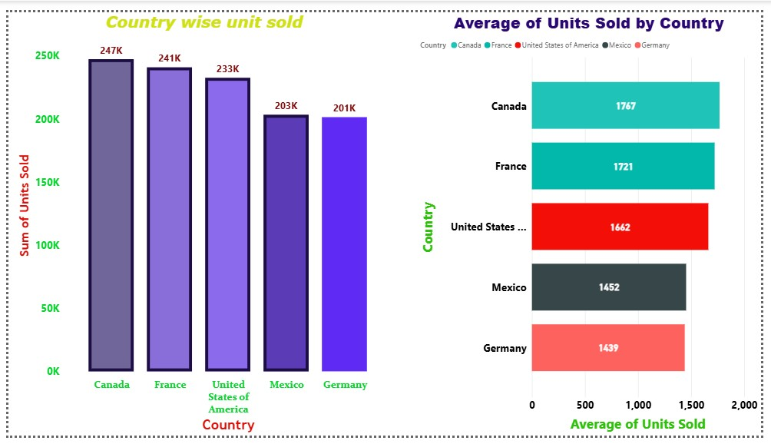

**Country wise units sold:**

# Step 1: Create the chart

* Go to the report view
* from the visualizations pane, select the clustered column chart icon
* set the fields:

▪ Drag country to the x axis ▪ Drag units sold to the y axis

# step 2: customize colors

* click the chart which one want to format
* in the build visual section, click the format visual
* open x axis àvalues
  + then I can change the x axis country names in to green color and also ▪ increase the font size
* if x axis title
  + go to visualizations pane àformat visualàtitle ON
* repeat the same steps for the y axis

# step 3: coloring column separately

* Visualizations pane à format visualà visualà columns
* Column is differs based on the chart I used column chart so it shows column
* Click each column and assign individual colors

# step 4: chart title

* default the chart title in random name like country by sum of units sold I want to change • go to the format visual à general àtitle • I changed the title to country wise units sold and
* Adjust the font size, color, set the center position

# Step 5: data labels

* Go to Visualizations pane à format visualà visualà data labels
* Turn ON if it’s off
* Click open data label increase the font size and set the label position

**Chart 2: Average units sold by country**

# Step 1: create the chart

* Go to the report view
* from the visualizations pane, select the stacked bar chart icon • set the fields:
  + Drag units sold to the x axis
  + Drag country to the y axis (change sum to average)

Repeat the step 2 to step 5 same process to this chart